Welcome to St. John the Evangelist Parish

MASS INTENTIONS
From Our Pastor

Saturday Dec. 19th
My dear friends in Christ,

5:00 p.m.Helen Ellis, Joe Ringwald, Becky Bullock,
___________ __Bob & Bernice Bullock, Vonda Elliott
Sunday Dec. 20th
8:00 a. m. Ed Lents
10:00 a.m. Jim Love, Raymond McCann,
Wilma Bateman, Alice Matthews
4:00 p.m. Ruth Ann Norris__________________
Monday St. John Dec. 21st
6:00 p.m. For the People ____________________
Tuesday Dec. 22nd
9:00 am. John J. Zins______________________
Wednesday Dec. 23rd 12:00 noon _ For the deceased members of the
William R. Cox family
Thursday Dec. 24th
2:00 p.m. _ See program
4:00 pm See program
12:00 Midnight____ _See program_____________
Friday Dec. 25th
9:00 a.m See program
4:00 p.m. See program
Saturday Dec. 26th
5:00 p.m. John C & Lucille A. Strange, Curt Elliott,
_____________Vonda Elliott, Leo W. & Catherine Arvin__
Sunday Dec. 27th
8:00 a. m. Dorothy Williams
10:00 a.m. Jo Ann Hogan, Mary Ann Nolan,
Joe & Delphia Nolan, Polly Walker
4:00 p.m. Gary Thompson_____________________

Ministers for Dec. 19th /20th 2020 9
SACRISTAN
5:00 p.m. Brady Lents
8:00 a.m. Bud Erler
10:00 a.m. Noel Harty
4:00 p.m. Volunteer
SERVERS:
5:00 p.m. Brady Lents, Alex Guinn
8:00 a.m. Dax Lee, Brianna Eckerle,
Curtis Merkley, Alex Merkley
10:00 a.m. Bryant Eckerle, John Paul Hart, Clayton Miller
4:00 p.m. Volunteer
LECTOR:
5:00 p.m. Kenny Inman
8:00 a.m. Peg Neidigh
10:00 a.m. Andy Ringwald
4:00 p.m. Isaac Lagree
EUCHARISTIC MINISTER:
5:00 p.m. Elaine Wade
8:00 a.m. Bernie Smith
10:00 a.m. Bill Boyd
4:00 p.m. Volunteer

Forth Sunday of Advent Week Prayer
O Wisdom, holy Word of God,
Jesus Christ,
all things are in your hands,
come and show us the way to salvation.

We are most grateful to Sandy Woods who created our outside nativity scene. She single-handedly designed and built the beautiful manger scene that we continue to use. The nativity statues were a gift from Aggie Cooper, in honor of her late husband and daughter.

This Sunday evening December 20th be certain to drive along the highway side of the church to enjoy our life nativity scene. A special thank you to Jackie Esch for involving our youth in this devotion.

Please note the Mass schedule for Christmas. We will have two children’s Masses on Christmas Eve: one at 2:00 and the other at 4:00. Midnight Mass will be at midnight and then on Christmas Day, our Masses will be at 9:00 in the morning and 4:00 in the afternoon.
A Blessed Christmas to all of you!! You and your families are being remembered in my Masses of Christmas.

The Holy Sacrifice of the Mass will be offered December 28th at 6:00 pm at St. John. As we celebrate the Feast of the Holy Innocents, this year we will be remembering children who were lost in death through miscarriage, stillbirth, abortion, and suicide. We want to reach out as a parish and support our hurting families.
May the Lord bless and keep you,
Father Walker.
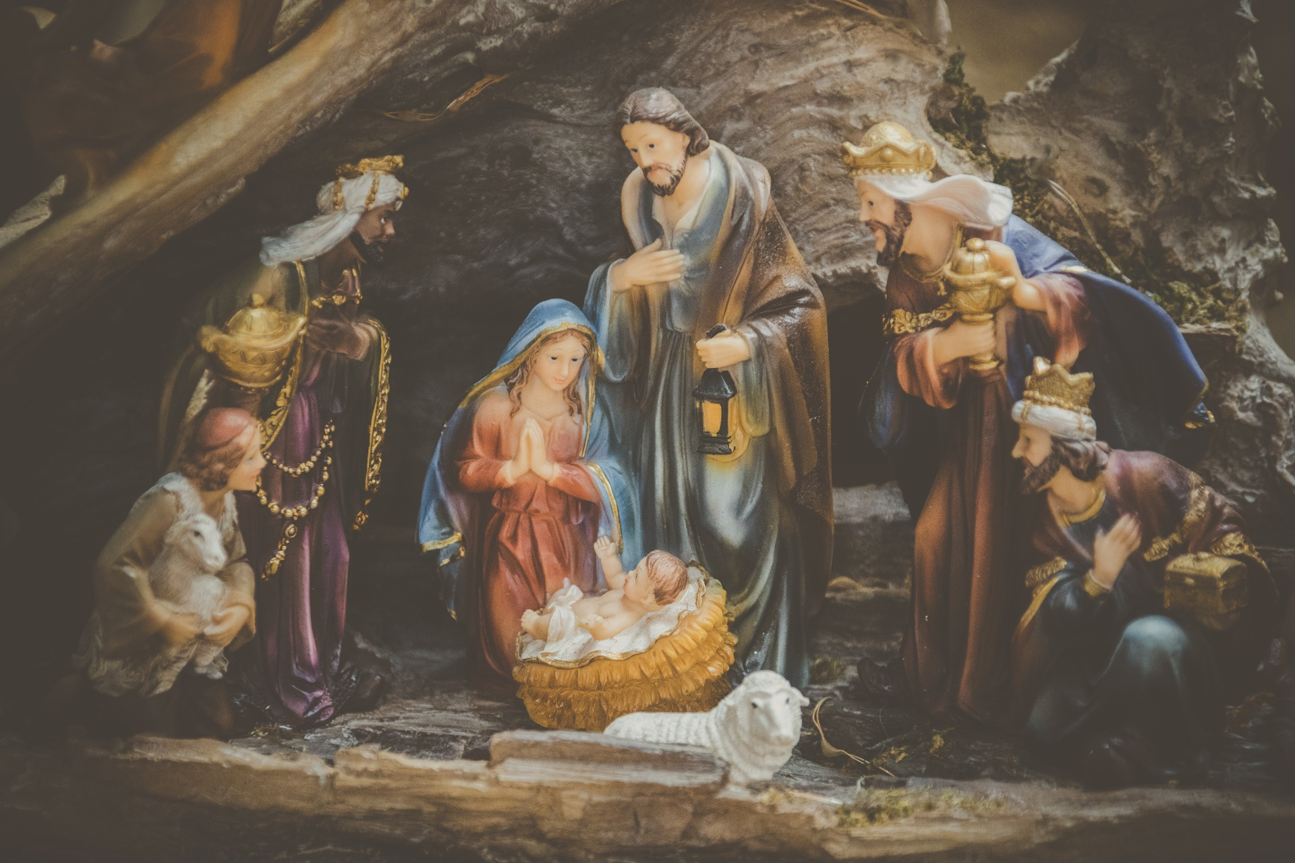

We will continue to livestream our Masses.
The daily Mass and Rosary is available on
Facebook at :
St John Catholic Parish Loogootee
Religious Education & Youth News with Jackie FA ITH FORMATION jesch@evdio.org
Religion
It’s hard to believe we have completed the first semester of religion classes already! There were so many times when I thought we would be forced into virtual classes at a moment’s notice, but we weren’t. Praise God!!! Please, keep the following people in your prayers of gratitude. They have worked so hard to keep our classes going and our facilities safe and healthy for the Catechism classes we have had so far. Cam Ackerman cleans and sanitizes often, Linda Lett takes temps on Mondays and helps serve food every Wednesday evening, Brian Esch cleans and sanitizes at St. Martin’s Hall, Suzettea Jones takes temps on Wednesday evenings, and all of our Catechists teach our kids and help out to sub in classes that are missing leaders due to quarantining. We are blessed to have these individuals serving to meet the needs of our religious education program. May you all have a blessed Christmas and enjoy celebrating the birth of our King!
Virtual Religion/Family Faith Formation Plans for the week of 12/13/20
https://docs.google.com/document/d/1AXJDR5wnepcbEm9O0g9vx-O8Rqyq7HhhJuqgyXOrRqc/edit?usp=sharing

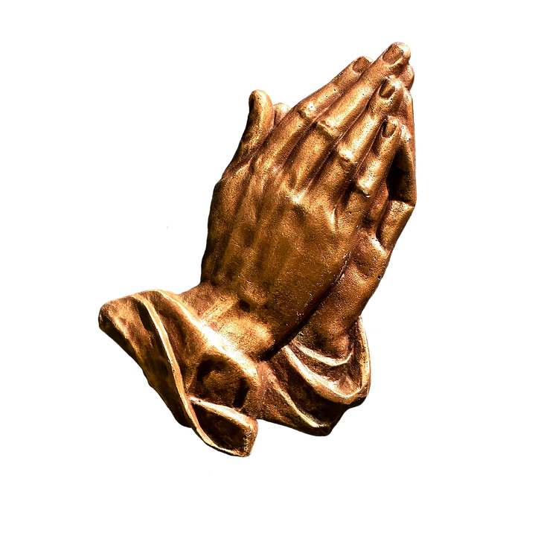 | Confessions anytime by appointment  ---------  Confessions: 12/26/2020  3:00 to 4:00

A mask is required at all parish meetings.


Ministers for Dec. 26th /27th 2020 9
SACRISTAN
5:00 p.m. Susan Ackerman
8:00 a.m. Bud Erler
10:00 a.m. Noel Harty
4:00 p.m. Volunteer
SERVERS:
5:00 p.m. Noah Esch, Cameron Burns, Noah Hager
8:00 a.m. Matthew, Ashley, Brendan, &Savannah Green
10:00 a.m. Xavier and Declan Todd
4:00 p.m. Volunteer
LECTOR:
5:00 p.m. Francis Doyle
8:00 a.m. Tom Peter
10:00 a.m. Kay Summers
4:00 p.m. Volunteer
EUCHARISTIC MINISTER:
5:00 p.m. Pat Daugherty
8:00 a.m. Bud Erler
10:00 a.m. Chris Burch
4:00 p.m. Volunteer

Save the Datedatedatedateda
Adult Bible Study – cancelled until January
Anointing of the Sick- Dec.19 &20 after Masses.
Sunday Dec. 20 & Monday Dec. 21- No Religion
Praise Choir- Dec. 20, 6-7 maybe longer
Praise Choir- Dec. 23, 6-7
The Sisters of the Little Company of Mary were founded 143 years ago by Venerable Mary Potter. Their name and mission were inspired by Mary, the mother of Jesus, and the little company of faithful followers who remained with her at the foot of the cross on Calvary, offering Jesus and Mary their compassionate presence. To this day, they continue to live out their healing mission of Jesus through prayer, presence and care for the sick, poor, unwanted and dying. They invite others to pray with them in that same charism, in their life lived out, and always in union with Mary our Mother. We invite you to learn more about this wonderful Little Company of Mary, Venerable Mary Potter, and the Devotions of Prayers for the Dying by picking up free items in the Parish Nursing Office in the Center.

Sunday Collection Dec.12th /13th 20200
St. John 128 envelopes (805 families) $8,997.97
Retired Religious Fund 536.00

December Birthdays of St. John the Evangelist Parish

December 1:
Ron Boyd
Christina Bratton
Corey Jacobs
Audrey Robinson
Jalen Wildman
Jordan Wildman

December 2:
Gayle Berry
Adam Graber
William Hunt
Brenda Mathies
David Ramsey
Susan Strange
Anderson Williams

December 3:
Ann Ackerman
Michael Wade
December 4:
Lisa Arvin
Rex Arvin
Scott Arvin
Savannah Harmon
Bobbi Sue Nonte
Jessica Padgett

December 5:
Jake Blackwell
William Boyd
Noah Hager
Lonnie Hawkins
Tim Miller
Alice Strange
James Vance

December 6:
Jake Carrico
Justin Clark
Cameron Hedrick
Donna Strange

December 7:
Ryan Letherman
Lathen Letterman
Josie Mathies
Chris Mattingly
Clare Ringwald
Rachel Robinson
Caleb Sward

December 8:
Kevin Bateman
Ann Holland

December 9:
Marie Sue Jones
Brogan Parker
Nancy Smith

December 10:
Nicholas Bowling
Timothy Dant
Isabella Hager
Chelsea Lannan

December 11:
Debbie Christmas
Shirley Fellers
Susan Jacobs

December 12:
Lynn Bateman
Noel Harty
Ethel McGuire
Thomas Michaels
Lori Wininger

December 13:
Jim Ellis

December 14:
Liam Kluesner
Roger Slaven
Kay Summers

December 15:
Kevin Lents
Katherine Love
Charles Rasico
Whitney Wagoner

December 16:
Charles Bridgewater
Michael Coulter
Kyle Wade

December 17:
Talan Hayes
Georgette Sutton
Seth Taylor

December 18:
Sandra Burch
Jared Lee
Ryan Mathias
Brooklyn Summers

December 19:
Grace Foddrill
Susie Hager
Meagan Holder
Justin Horney
Martin Lannan
Mary Lannan
Sharon Sims
Olivia Smiley

December 20:
Maddelyn Dalrymple
Isaac Lagree
Emily Sutton
Gina Toy

December 21:
Mitch Jeffers
James Sullivan
Makenzie VanHoy

December 22:
Mattie Milligan
Donna Rayhill

December 23:
Aaron Dant
Barb Hyllested

December 24:
Dola Francyne Fegan

December 25:
Jessie Carter
Falicia Hollaway
Marilyn Horsting
Amy Williams

December 26:
Cathy Arvin
Marty Arvin
Angie Brookshire
Patrick Wagler
Rosie Wininger

December 27:
Andrew Burch
Luke Jones

December 28:
Megan Miller
Kristine Southard

December 29:
Marie Hawkins
Mary Sue Sterling
Sandy Woods

December 30:
Carolyn Buxton
Luke Callison
Erika Fellers
Amber Furhman
Melissa Hedrick
Landon Marks
Clint Williams
Julie Wittmer

December 31:
Julie Lagree
Garrett Williams

