Welcome to St. John the Evangelist Parish

MASS INTENTIONS
Saturday, Dec. 16th
5:00 p.m. Fred Dupps, Helen Ellis, Donna & Norma Arvin, Mary Kay Patterson
Sunday, Dec. 17th
8:00 a.m. Ed & Virginia Craney
10:00 a.m. Sid & Rose Queen, Jim Love,
Eric Baker (A), Jerome Matthews
4:00 p.m. Penance Service
Monday St. Martin Dec. 18th
12:00 Noon For the people
Tuesday, Dec. 19th
8:15 a.m. Alice Matthews
Wednesday Dec. 20th
5:30 p.m. Melinda Gates
Thursday, Dec. 21st
8:15 a.m. Mary Jane Ryan
6:00 p.m. Penance Service
Friday, Dec. 22nd
8:15 a.m. Bob Bullock
Saturday, Dec. 23rd
5:00 p.m. Raymond McCann, Becky Bullock,
Wilma Bateman, William “Bill” Cox
Sunday, Dec. 24th
8:00 a.m. Larry Lasher
10:00 a.m. Bob Mills, Katie Yarnell ,
George “Tony” Sims, Terry Bowling
4:00 p.m. See program
12:00 midnight See program
Ministers for Dec. 16th /17th 2017 5
SACRISTANS
5:00 p.m. Judy Ader
8:00 a.m. George Erler
10:00 a.m. Glenn McAtee
SERVERS:
5:00 p.m. Jamison Hennette, Brady Lents, Cameron Burns, Rachel Lents, Jonathan Hager
8:00 a.m. Jason/Craig Lubbehusen, Grace Foddrill, Volunteer
10:00 a.m. Sean Lents, Aaron Dant, Seth Blackwell, Euan Graves
GREETERS:
5:00 p.m. FD: Joe and Vicky Doyle
SD: Rachel Doyle, Sue Morrison
8:00 a.m. FD: John and Diane Vaupel
SD: Helen Dearwester, Volunteer
10:00 a.m. FD: Faye Holland
SD: Dan and Barbara Gregory
LECTORS:
5:00 p.m. Brenda Dant, Brandon Eckerle
8:00 a.m. Betty Huelsman, Tom Peter
10:00 a.m. John A. Walker ,Rhi Graves
EUCHARISTIC MINISTERS:
5:00 p.m. Charles and Carolyn Buxton, Linda Wickman, Janet Matthews, Donna Ader, Tom Walker, Patrick Allbright
8:00 a.m. George Erler, Jerry Lubbehusen, Peg Neidigh, Tom Peter, Jerry/Betty Huelsman, Rita Divine
10:00 a.m. Karen McAtee, Curt Johnson, Dayne Holder, Gayle Strange, Peter McDowell, Greg Rasico, Volunteer
From Our Pastor
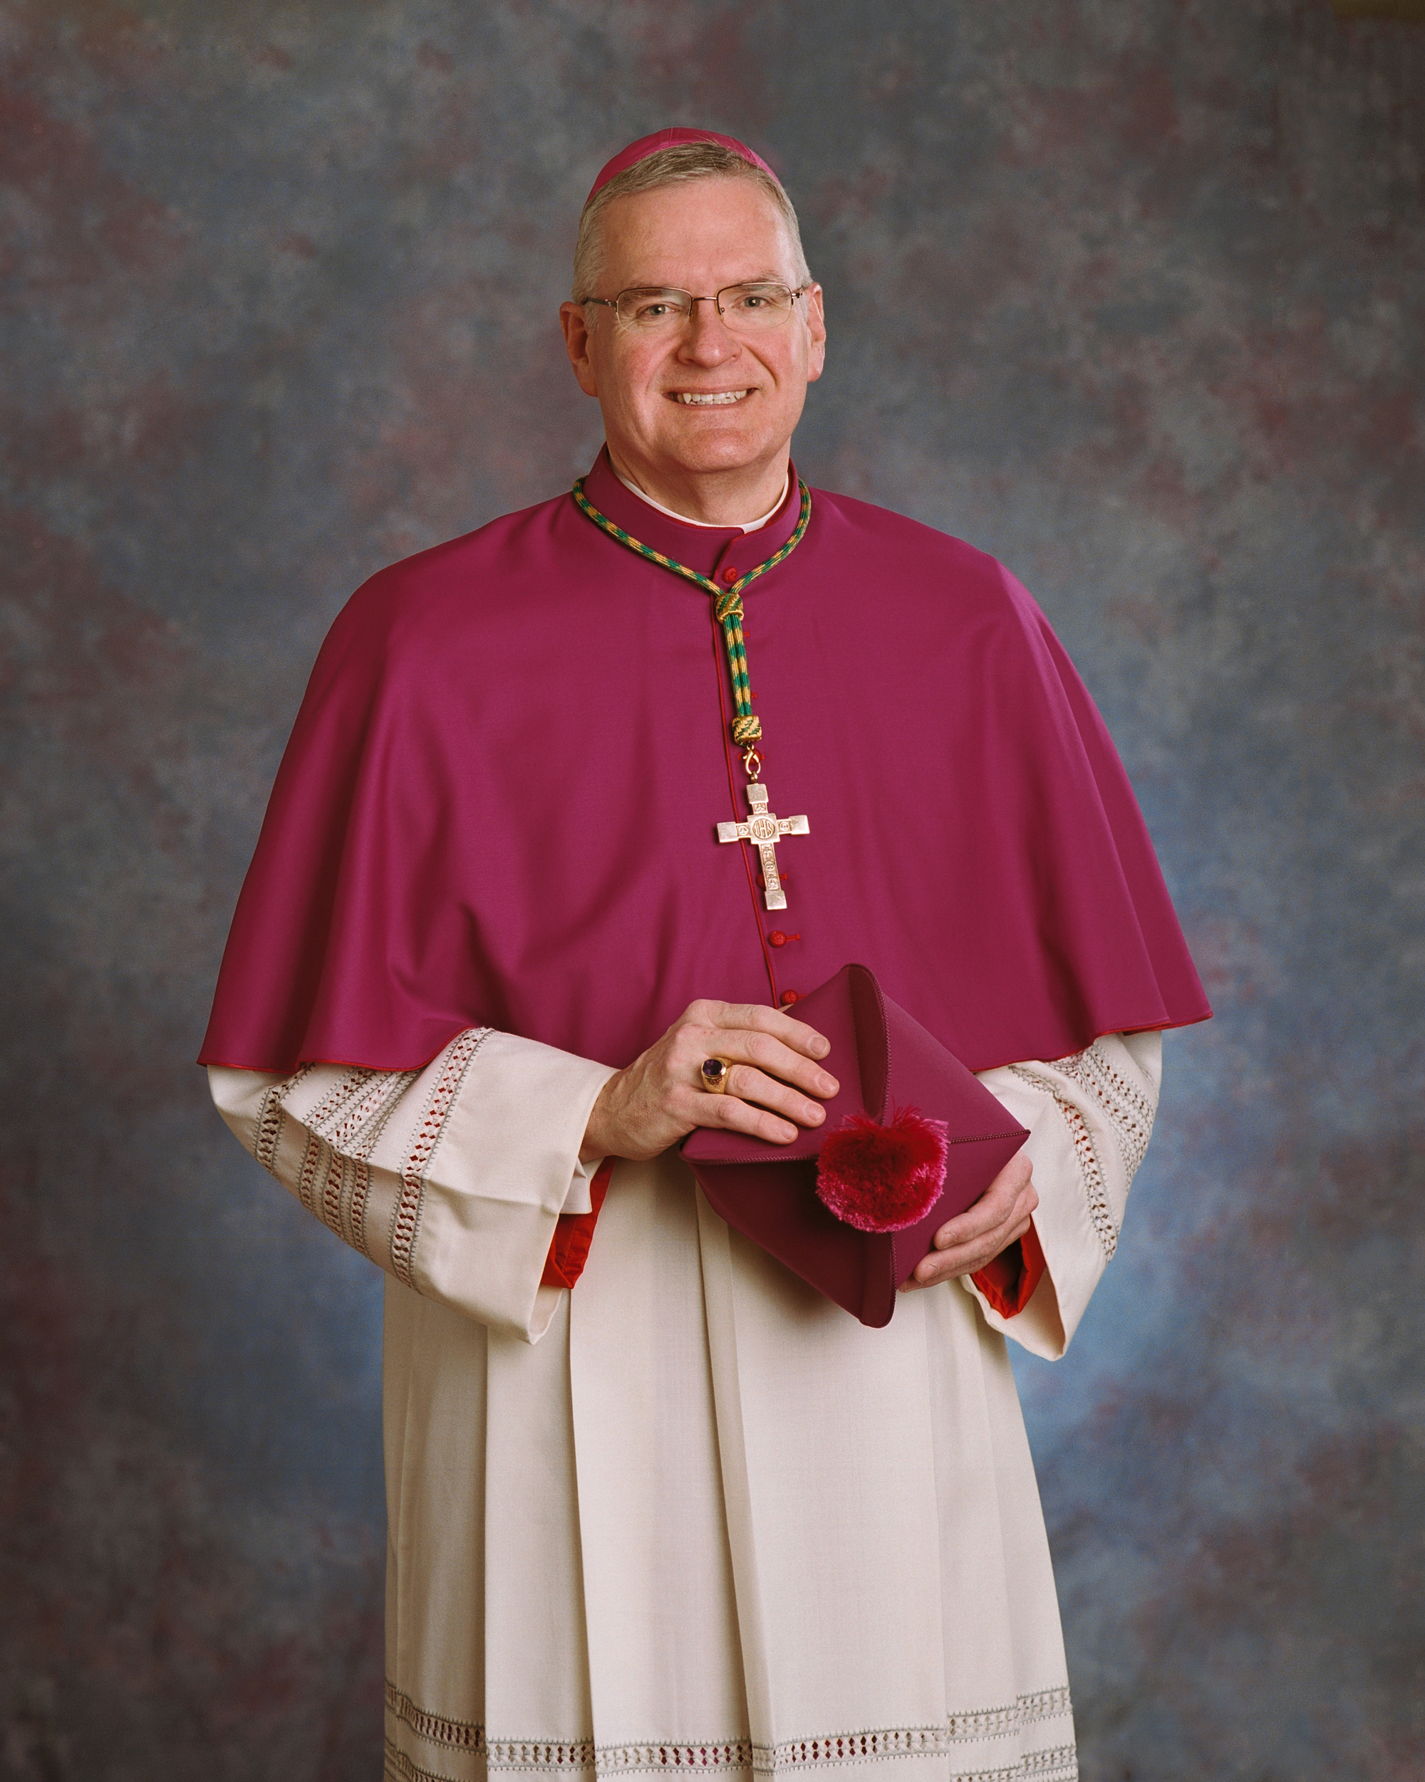
Bishop Siegel’s Episcopal Motto:
“In you Lord, I have placed my hope.”
As I am writing this I am looking forward to the Solemn Evening Prayer Thursday evening and the Mass of Installation on Friday for Bishop Joseph M. Siegel, D.D., S.T.L., as the sixth bishop of the Diocese of Evansville.
Saturday, December 16th we celebrated the funeral Mass for Judy Rasico. Judy graduated from St. John High School and was a life-time member of our parish. Judy and her husband, Greg were married for 54 years and were blessed with 4 children. Judy was a cantor at St. John for over 50 years and was known and appreciated for her beautiful voice. Judy truly was a person who thought of other people before herself and will be greatly missed. May she rest in peace. Amen.
Thank you for your generous support of the Stewards of God’s Grace Capital Campaign. To date we have pledges and or cash totaling $1,003,901.76. I appreciate everyone’s cooperation and involvement. We continue to work together to make our Lord more present in our community and the diocese. Please pray about your gift as we thank Almighty God for all that He has given us!
To help us get ready for Christmas there will be the opportunity for the Anointing of the Sick after all the Masses this weekend. We will also have a parish Penance service on Sunday, December 17th at 4:00 p.m. and Thursday, December 21st at 6:00 p.m.. Let us continue to use these days of Advent to prepare for a re-birth of the Lord Jesus in our lives.

May the Lord bless and keep you,
Father Walker.
This Week at St. John Parish .
Sunday, Dec. 17th
Anointing of the Sick after all the Masses
Confirmation- 9:45 at the Center
Liturgy of the Word- 10:00 Mass
Penance Service -4:00 p.m.
Monday, Dec.18th
(B) St. Joseph Eucharistic Adoration 9:00 am to 12:
(S) St. Mary Eucharistic Adoration 9:00 am to 12:00
Quilters, 11:00 am - 3:00 pm.
(W) Mass at St. Martin at 12:00 Noon
Elem. Religion- 3:30 to 4:30 at Loog. Elem. School
Women’s Cursillo Grouping-5:00
Senior Choir – 6:00
Cub Scouts Meeting-7:00 at the Center
Tuesday, Dec. 19th
(L)Rosary: 7:45-8:15a.m.
Wednesday, Dec. 20th
(W) St. Martin Eucharistic Adoration-3:00 pm to 6:00
Jr. /Sr. High Religion Classes-NO CLASS
Thursday, Dec. 21st
Rosary: 7:45-8:15a.m.
(L) Eucharistic Adoration after 9:00 Mass - 4:30 pm.
Youth Prayer Group-3:30 p.m.
Penance Service- 6:00
Senior Choir Practice- 7:00
Friday, Dec. 22nd
Quilters, 11:00 am - 3:00 pm.
Saturday, Dec. 23rd
Private Confessions –3:15 to 4:00pm
Sunday, Dec. 24th
No Confirmation Class
No Liturgy of the Word

Religious Education News with Paula Ringwald FAITHFORMATION pringwald@evdio.org
Religion Classes will resume: January 14th-9th Grade Confirmation, January 15th-Elementary, January 17th-Jr. Sr. High

The St. Vincent DePaul Food Pantry is asking for your assistance in helping to provide food for over 200 families in Martin County. Boxes will be at the St. John Center on Saturday Dec. 9th through Sunday Dec.17th. Non-perishable food items are needed. Thank-you in advance for your generosity. Please drop your non-perishable items at the St. John Center.
Here are some up-coming Masses & events:
* Anointing of the Sick- Dec.16th & 17th
- Advent Penance Services- December 17th Sunday 4:00 & Dec. 21st at 6:00
- Christmas Quilt raffle- Dec. 17
- Regular Weekend before Christmas-
Saturday Dec. 23rd at 5:00 p.m.
Sunday Dec. 24th at 8:00a.m. and 10:00 a.m.
Christmas Masses- Dec. 24th -
4:00 p.m. & 12:00 Midnight,
- Dec. 25th at 9:00 a.m. and 4:00 p.m.
Save the Date m
-Story Hour: Dec. 27 from 10-11:00 “Baby Moses”
-First Saturday Devotion-January 6; Confession at 11, Rosary at 11:30, Mass at 12:00
-Religion Teacher Training-January 10th from 6-8:30
-Adult Bible Study-January 14th at 5:30 Lesson 15
-Parish Council & Teacher Appreciation Epiphany Party-January 19th at 6:00 at Gasthof.

Christmas Mass Intentions- There is not a limit for the Mass intentions which are allowed for Christmas. Therefore, we may have multiple intentions listed for each of the Christmas Masses. If you would like a Mass offered for your deceased loved one , please call the parish office at 812-295-2225 and speak to Vicki.

Ministers for Dec. 23rd /24th 2017 5
SACRISTANS
5:00 p.m. Chuck and Carolyn Buxton
8:00 a.m. George Erler
10:00 a.m. Samantha Nelson
SERVERS:
5:00 p.m. Jamison Hennette, Brady Lents, Noah Esch, Cassidy Esch, Madison Esch
8:00 a.m. Adie Nolley, Matthew Green, Ashley Green, Volunteer
10:00 a.m. Logan Jacobs, Alex Bowling, Nathaniel Hart, John Paul Hart, Abbi Nonte
GREETERS:
5:00 p.m. FD: Barbara Stoll
SD: Volunteers
8:00 a.m. FD: Doug and Peg Neidigh
SD: Leo Padgett family
10:00 a.m. FD: JD and Lori Flynn
SD: Jarrett Arvin, Lonnie Hawkins
LECTORS:
5:00 p.m. Jamison Hennette, Kenny Inman
8:00 a.m. Jerry Padgett, George Erler
10:00 a.m. Kylie VanHoy, Lori Flynn
EUCHARISTIC MINISTERS:
5:00 p.m. Elaine Wade, Diana Schutte, Pat Daugherty,
Inger Johnson, Patrick Allbright, John Crays, Volunteer
8:00 a.m. Bruce/Lynn Hawkins, Annette Taylor, Richard Kluesner, Jan McDowell, Donna Heshelman, Jill Wininger
10:00 a.m. Tom/Stephanie McAtee, Greg/Lynn Bateman,
Brenda Mathias, Lori Flynn, Andy Ringwald

Sunday Collection Dec. 9th /10th 2017 n
St. John 202 envelopes (869 families) $9,724.00
Religious Retirement 565.00

Youth News with Mark Potts ss
Upcoming Events for the Youth Group:
Toy Store (Possible Confirmation Hours) – Dec 16th
Pizza and A Movie: December 28th
Campaign Corner -Pledged $1,003,901.76 Make checks payable to Stewards of God’s Grace

Sick List for St. John the Evangelist Parish

Helen Acton
Robert Allen
Vicky Allen
Lynette Arvin
Marilyn Arvin
Jim Bateman
Dee Bechtel
John Blanton
Charles Blessinger
Dorothy Blessinger
Claudia & Jim Bennett
Michael Bowers
Don Bowling
Barbara, Jr., Larry & Wyatt Boyd
Wanda Bradley
Avaley Braun
Chuck Bries
Laura Ann Brown
Jane Bruner
Bernice Bullock
Mary Charlene Burr
Don Cave
Roberta Cooper
Tim Consley
Jerry Craney
Wesley Crays
Linda Cresgy
Mary Jane Crew
Vic Crew
Dennis Crop
Ed David
Sr. Lorraine Devault
Joe and Vicky Doyle
Ruth Durlauf
Cindy Dwyer
Mary Jo Dyer
Debbie Dyal
Doyle Elliott
Philip Erler
Betty, John, & Mike Ervin
Jill Ernst
Jeff Farrell
Ken Fleming
Dorothy Flynn
Mary Fowler
Mary Gabbert
Anne Gebhardt
Dr. Jean Walker Godfrey
Dianna Gottwalles
Amanda and Eli Grafton
Beth Ann and Clara Grafton
Manfred Groemminger
Jeff Grube
Joan Haag
Shanna and Shirley Harding
Michael, Pat, & Roy Hawkins
Jenny Hembree
Mila Hornstein
Paul Hornstein
Nancy Hopkins
Pauline Hotz
Jane Hovis
David Johnson
Megan Johnson
Dana (Tow) Jones
JJ (Jim) Jones
Jeff & Mona Jones
Irene Kaiser
Fr. Leo
Mary Evelyn Lankford
James Lannan
Kenny Lannan
Patty Lannan
Mark Lehmkuhler
Ryan Lents
Mary Louise Lentz
Betty Lindley
Kay Love
Nancy (Miller) Marlow
Devon Marner
Margaret Mathies
Ann McAtee
Bob McGuire
Jim & Sue Morrison
Alice Myrum
Colin Nelson
Jennifer Neumann
George Nolan
Phyllis Norris
Austin O’Connor
Riley Osmon
Emil Oster
Pam Owens
Brian Padgett
Jim Pankey
Deb Parsons
Teresa Pevlor
Meg Pew
Jiggs Pieper
Georgia Anna Ragsdale
Charles Rasico
Larry Rayman
John Richardson
Roaslie Riggins
Jackie Robertson
Mary Grace Schnarr
Sarah Schoenbaechler
Edel Traut Schubert
Linda Schwager
Marie C. Seifert
Bill, Carson, Jonah, Kenley, & Terry Shaw
Eddie Sims
Mary Lou Sims
Rob Smith
Adam Sorensen
Leo Sorensen
Dale & Inez Sorrells
Margaret Spalding
Peggy Spalding
Susie Stemle
Freda Stringer
Rosemary Stuckey
Bonnie and Joe Summers
Dr. Larry Sutton
Carolyn Taylor
Daniel Taylor
Tony Taylor
Maureen Thomas
Chelsea Tinkle
Kevin and Liz Tinkle
Troy Tow
Kallin Trambaugh
Karcyn Trambaugh
Frances Trout
Bill Vaughan
William Wagoner
Tom Wagner
Brittany Walker
Rita Weaver
Rob Webster
Bobbie White
Ruby Wilcoxen
Georgia Wininger
Bill Wolf
Rodney Wright

December Birthdays of St. John the Evangelist Parish

December 1:
Ron Boyd
Christina Bratton
Corey Jacobs
Audrey Robinson
Jalen Wildman
Jordan Wildman

December 2:
Gayle Berry
Adam Graber
William Hunt
Jerry Kemp
Brenda Mathies
David Ramsey
Susan Strange
Anderson Williams

December 3:
Ann Ackerman
Michael Wade

December 4:
Lisa Arvin
Rex Arvin
Scott Arvin
Savannah Harmon
Bobbi Sue Nonte
Jessica Padgett

December 5:
Jake Blackwell
William Boyd
James E. Burch
Noah Hager
Lonnie Hawkins
Tim Miller
Alice Strange
James Vance

December 6:
Jake Carrico
Justin Clark
Cameron Hedrick
Donna Strange

December 7:
Lathen Letterman
Josie Mathies
Chris Mattingly
Clare Ringwald
Rachel Robinson
Caleb Sward

December 8:
Ann Holland

December 9:
Marie Sue Jones
Brogan Parker
Nancy Smith
December 10:
Nicholas Bowling
Timothy Dant
Isabella Hager
Chelsea Lannan
Inez Sorrells

December 11: Debbie Christmas
Shirley Fellers
Susan Jacobs

December 12:
Lynn Bateman
Noel Harty
Ethel McGuire
Thomas Michaels
Lori Wininger

December 13:
Jim Ellis

December 14:
Liam Kluesner
Roger Slaven
Kay Summers

December 15:
Kevin Lents
Katherine Love
Charles Rasico
Whitney Wagoner

December 16:
Charles Bridgewater
Michael Coulter
Kyle Wade

December 17:
Talan Hayes
Georgette Sutton
Seth Taylor

December 18:
Sandra Burch
Ryan Mathias
Brooklyn Summers

December 19:
Grace Foddrill
Susie Hager
Meagan Holder
Justin Horney
Martin Lannan
Mary Lannan
Sharon Sims

December 20:
Maddelyn Dalrymple
Isaac Lagree
Emily Sutton
Gina Toy

December 21:
Mitch Jeffers
Makenzie VanHoy

December 22:
Mattie Milligan
Donna Rayhill
Morris Trowbridge

December 23:
Aaron Dant
Barb Hyllested

December 24:
Dola Francyne Fegan
Betty Wessel

December 25:
Jessie Carter
Falicia Hollaway
Marilyn Horsting
Amy Williams

December 26:
Cathy Arvin
Marty Arvin
Angie Brookshire
Patrick Wagler
Rosie Wininger

December 27:
Andrew Burch
Luke Jones
Mary Evelyn Lankford

December 28:
James Bradley
Megan Miller
Kristine Southard

December 29:
Marie Hawkins
Mary Sue Sterling
Sandy Woods

December 30:
Carolyn Buxton
Luke Callison
Erika Fellers
Amber Furhman
Melissa Hedrick
Landon Marks
Clint Williams
Julie Wittmer

December 31:
Julie Lagree
Garrett Williams

