Welcome to St. John the Evangelist Parish

MASS INTENTIONS
Saturday, Dec. 9th
5:00 p.m. Ann Burch, Walter & Anna M. Todd,
Charles & Oenone Bradley, Jacob Bradley
Sunday, Dec. 10th
8:00 a.m. Jean & Steve Ellis
10:00 a.m. David Decker, Ellen Smith,
Terry Bowling, George “Tony” Sims
Monday St. Mary Dec. 11th
12:00 Noon For the people
Tuesday, Dec. 12th
8:15 a.m. Dana Purdy
Wednesday Dec. 13th
5:30 p.m. Eric J. Miller
Thursday, Dec. 14th
8:15 a.m. Bob Van Winkle
Friday, Dec. 15th
8:15 a.m. No Mass
Saturday, Dec. 16th
5:00 p.m. Fred Dupps, Mary Kay Patterson, Donna & Norma Arvin, Helen Ellis,
Sunday, Dec. 17th
8:00 a.m. Ed & Virginia Craney
10:00 a.m. Sid & Rose Queen, Jim Love,
Eric Baker (A), Jerome Matthews
4:00 p.m. Penance Service
Ministers for Dec. 9th /10th 2017 5
SACRISTANS
5:00 p.m. Rachel Doyle
8:00 a.m. George Erler
10:00 a.m. Noel Harty
SERVERS:
5:00 p.m. Jamison Hennette, Brady Lents,
Brandon Eckerle, Bryant Eckerle, Alex Guinn
8:00 a.m. Adie Nolley, Matthew Green, Ashley Green, Volunteer
10:00 a.m. Rachel Robinson, Kylie VanHoy,
Jody/Nathan Seals, Ashlee Arvin
GREETERS:
5:00 p.m. FD: Anne Marie Crays
SD: Joyce Conlon, Volunteer
8:00 a.m. FD: Jerry and Betty Huelsman
SD: Annette Taylor, Alice Boyd
10:00 a.m. FD: Robinson Family
SD: Abbie Williams, Denny Smith
LECTORS:
5:00 p.m. Tom Walker, Allyson Mudd
8:00 a.m. Peg Neidigh, Jerry Lubbehusen
10:00 a.m. Kay Summers, Gil Toy
EUCHARISTIC MINISTERS:
5:00 p.m. Elaine Wade, Diana Schutte, Pat Daugherty,
Inger Johnson, Patrick Allbright, John Crays, Volunteer
8:00 a.m. Bruce/Lynn Hawkins, Richard Kluesner,
Jan McDowell, Donna Heshelman, Jill Wininger, Bernie Smith
10:00 a.m. Tom/Stephanie McAtee, Greg/Lynn Bateman,
Brenda Mathias, Lori Flynn, Andy Ringwald
Sunday Collection Dec. 2nd / 3rd 2017 n
St. John 252 envelopes (869 families) $10,482.01
From Our Pastor
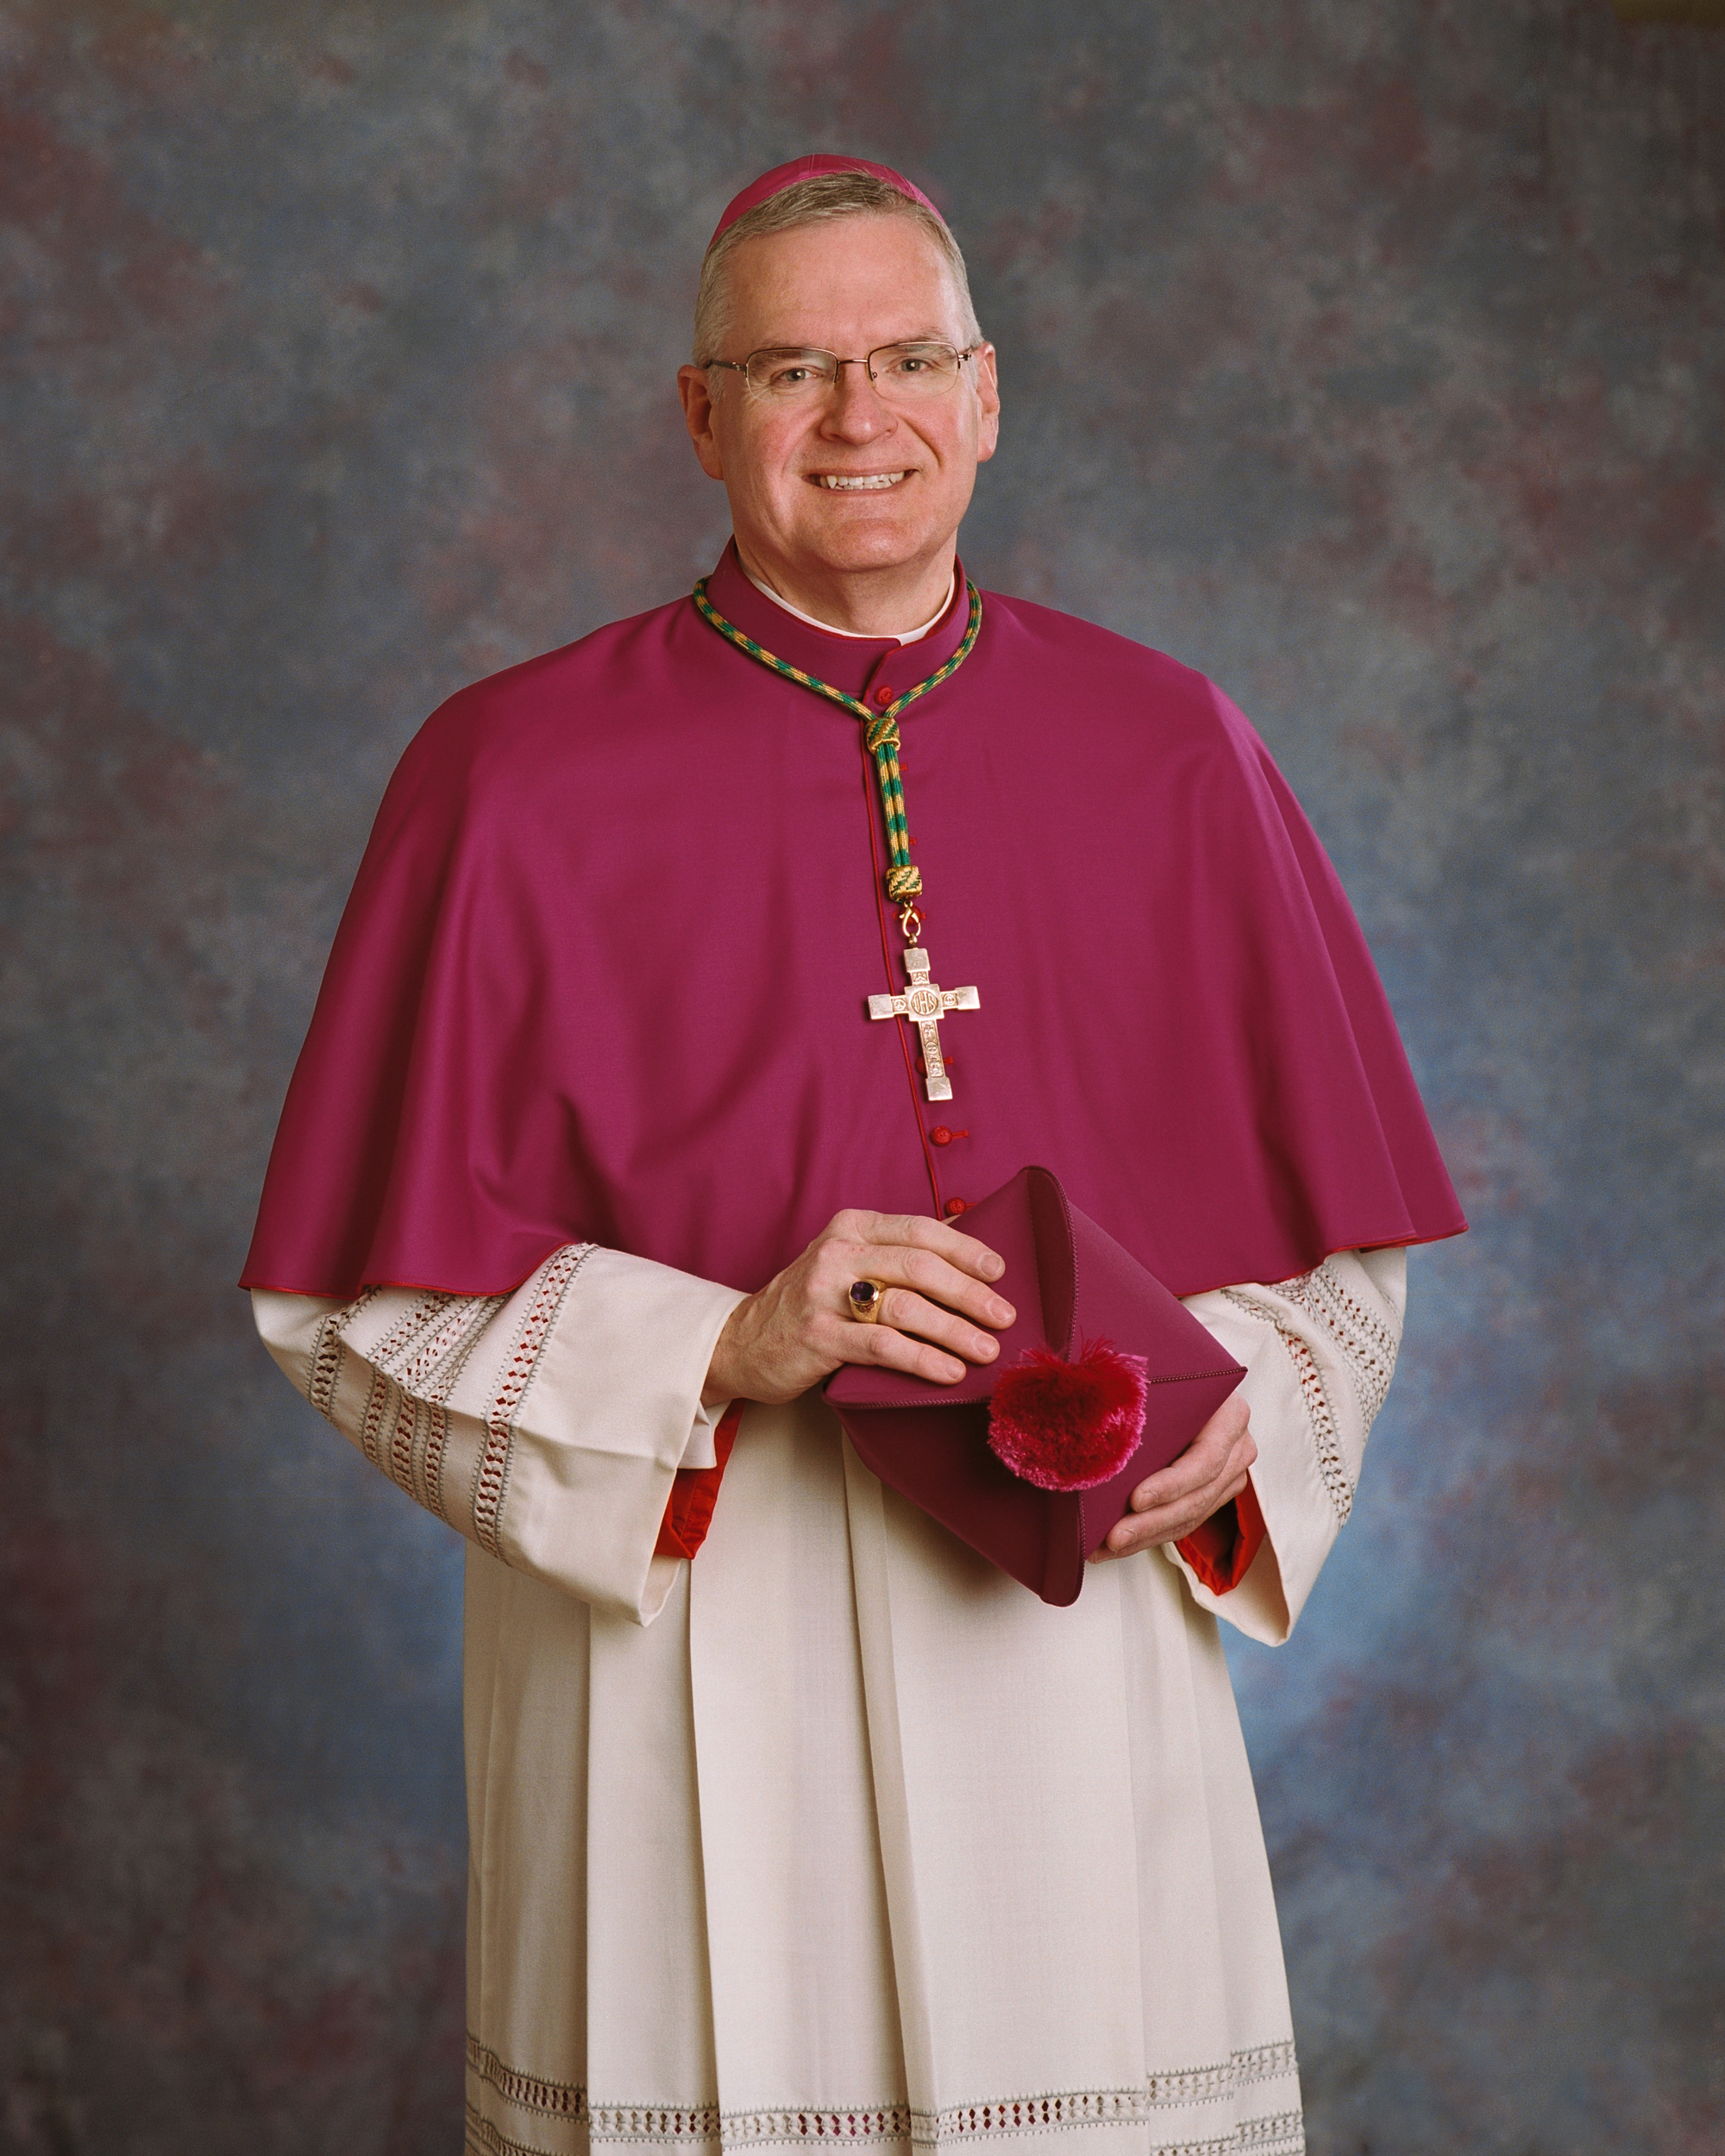
The installation for Bishop Joseph M. Siegel, D.D., S.T.L. will be on Friday, December 15th at 2:00 (CST) at St. Benedict Cathedral in Evansville.
Bishop Siegel’s Episcopal Motto:
“In you Lord, I have placed my hope.”
Thank you for your generous support of the Stewards of God’s Grace Capital Campaign. To date we have pledges and or cash totaling $999,001.76. We now have achieved over 187% of the goal which means anything over $669,555.00 will be returned to the parish 100%. I appreciate everyone’s cooperation and involvement. We continue to work together to make our Lord more present in our community and the diocese. We do plan to contact every household of the parish. Please pray about your gift as we thank Almighty God for all that He has given us!
This past Saturday, Dec. 2nd was the 19th annual St. Nick Meal. They have prepared and delivered over 8000 Christmas Celebration Meals to the needy residents, shut-ins and senior citizens of Martin and Daviess Counties. This event is spearheaded by Tom & Jean Walker, along with many others who have been instrumental in this endeavor for years. Mark Potts and our Youth Group also worked with preparing the carry-out meals which is a wonderful help.
I am very proud to report that our parish won the Best Float Award for the “True Meaning of Christmas”--Gifts of Love in our Loogootee Christmas parade. The committee who made all of this possible was made up of: Kay Summers, Sandy Woods, Paula Ringwald, Jackie Esch, and Chris Rahman. Joleen McAtee lended a lot of her supplies and Katie & Mike Milligan made their large garage available for us to use. Lance Mathias and Mathias Farms supplied their hay wagon and Lance Mathias drove the float with his truck. It was wonderful to have so many of our youth participating in the parade with such a tremendous spirit! I appreciate all that Mark Potts does with our youth and we are blessed to have such fine young people in our parish.
A heartfelt thank you to all who contributed to make our parish Christmas float so beautiful and meaningful. It certainly brought joy to my life!
the Lord bless and keep you, Father Walker.
Campaign Corner -Pledged $999,001.76 Make checks payable to Stewards of God’s Grace
This Week at St. John Parish .
Sunday, Dec. 10th
Confirmation- 9:45 at the Center
Liturgy of the Word- 10:00 Mass
Senior Choir Practice- after 10:00 Mass
No Praise Youth Choir Practice
Monday, Dec.11th
(B) St. Joseph Eucharistic Adoration 9:00 am to 12:00
Quilters, 11:00 am - 3:00 pm.
(S) Mass at St. Mary at 12:00 Noon
Circle of Peace Prayer Meeting- 1:00 p.m
Elem. Religion- 3:30 to 4:30 at Loog. Elem. School
Cub Scouts Meeting-7:00 at the Center
Altar Society-6:00 p.m.- Christmas
Catholic War Veterans- 6:00 We will be voting. Please come!
Tuesday, Dec. 12th
(L)Rosary: 7:45-8:15a.m.
Wednesday, Dec. 13th
(W) St. Martin Eucharistic Adoration-3:00 pm to 6:00
Blood Drive- Shoal’s Christian Church- 2:00 to 7:00
Jr. /Sr. High Religion Classes- 6:45 to 8:00 at the Center - Supper at 6:15
Thursday, Dec. 14th
Rosary: 7:45-8:15a.m.
(L) Eucharistic Adoration after 9:00 Mass - 4:30 pm.
Blood Drive- St John Center 2:00 to 7:00
Youth Prayer Group-3:30 p.m.
Senior Choir Practice- 5:00
Friday, Dec. 15th
Quilters, 11:00 am - 3:00 pm.
Saturday, Dec. 16th
Private Confessions –3:15 to 4:00pm
Sunday, Dec. 17th
Confirmation- 9:45 at the Center
Liturgy of the Word- 10:00 Mass
Penance Service -4:00 p.m.
Religious Education News with Paula Ringwald FAITH FORMATION pringwald@evdio.org
Penance Services still going on with youth.
The St. Vincent DePaul Food Pantry is asking for your assistance in helping to provide food for over 200 families in Martin County. Boxes will be at the St. John Center on Saturday Dec. 9th through Sunday Dec.17th. Non-perishable food items are needed. Thank-you in advance for your generosity. Please drop your non-perishable items at the St. John Center.
Here are some up-coming Masses & events:
* Anointing of the Sick- Dec.16th & 17th
- Advent Penance Services- December 17th Sunday 4:00 & Dec. 21st at 6:00
- Christmas Quilt raffle- Dec. 17
- Regular Weekend before Christmas-
Saturday Dec. 23rd at 5:00 p.m.
Sunday Dec. 24th at 8:00a.m. and 10:00 p.m.
Christmas Masses- Dec. 24th -
4:00 p.m. & 12:00 Midnight,
- Dec. 25th at 9:00 a.m. and 4:00 p.m.
Save the Date m
-Anointing of the Sick after all Masses: Dec. 16 & 17
-Parish Penance Service: Dec. 17 at 4:00 / Dec. 21 at 6:00
-LAST ELEM RELIGION CLASS-Dec.18
-LAST JR. SR. RELIGION CLASS-Dec. 20
-NO CONFIRMATION RELIGION CLASS on Dec. 24
-Story Hour: Dec. 27 from 10-11:00 “Baby Moses”
Christmas Mass Intentions- There is not a limit for the Mass intentions which are allowed for Christmas. Therefore, we may have multiple intentions listed for each of the Christmas Masses. If you would like a Mass offered for your deceased loved one , please call the parish office at 812-295-2225 and speak to Vicki.
Ministers for Dec. 16th /17th 2017 5
SACRISTANS
5:00 p.m. Judy Ader
8:00 a.m. George Erler
10:00 a.m. Glenn McAtee
SERVERS:
5:00 p.m. Jamison Hennette, Brady Lents, Cameron Burns, Rachel Lents, Jonathan Hager
8:00 a.m. Jason/Craig Lubbehusen, Grace Foddrill, Volunteer
10:00 a.m. Sean Lents, Aaron Dant, Seth Blackwell, Euan Graves
GREETERS:
5:00 p.m. FD: Joe and Vicky Doyle
SD: Rachel Doyle, Sue Morrison
8:00 a.m. FD: John and Diane Vaupel
SD: Helen Dearwester, Volunteer
10:00 a.m. FD: Faye Holland
SD: Dan and Barbara Gregory
LECTORS:
5:00 p.m. Brenda Dant, Brandon Eckerle
8:00 a.m. Betty Huelsman, Tom Peter
10:00 a.m. John A. Walker ,Rhi Graves
EUCHARISTIC MINISTERS:
5:00 p.m. Charles and Carolyn Buxton, Linda Wickman, Janet Matthews, Donna Ader, Tom Walker, Patrick Allbright
8:00 a.m. George Erler, Jerry Lubbehusen, Peg Neidigh, Tom Peter, Jerry/Betty Huelsman, Rita Divine
10:00 a.m. Karen McAtee, Curt Johnson, Dayne Holder, Gayle Strange, Peter McDowell, Greg Rasico, Volunteer
Youth News with Mark Potts ss
Upcoming Events for the Youth Group:
Toy Store (Possible Confirmation Hours) – Dec 16th
Pizza and A Movie: December 28th

Sick List for St. John the Evangelist Parish

Helen Acton
Robert Allen
Lynette Arvin
Marilyn Arvin
Dee Bechtel
Kenneth Bingemer
John Blanton
Charles Blessinger
Dorothy Blessinger
Claudia & Jim Bennett
Michael Bowers
Barbara, Jr., Larry & Wyatt Boyd
Wanda Bradley
Jim Bradley
Avaley Braun
Laura Ann Brown
Jane Bruner
Bernice Bullock
Mary Charlene Burr
Don Cave
Roberta Cooper
Tim Consley
Jerry Craney
Wesley Crays
Linda Cresgy
Mary Jane Crew
Ed David
Sr. Lorraine Devault
Joe and Vicky Doyle
Ruth Durlauf
Cindy Dwyer
Mary Jo Dyer
Debbie Dyal
Doyle Elliott
Philip Erler
Betty, John, & Mike Ervin
Jill Ernst
Ken Fleming
Dorothy Flynn
Mary Fowler
Anne Gebhardt
Dr. Jean Walker Godfrey
Dianna Gottwalles
Amanda Grafton
Eli Grafton
Manfred Groemminger
Jeff Grube
Joan Haag
Shanna and Shirley Harding
Michael, Pat, & Roy Hawkins
Jenny Hembree
Mila Hornstein
Paul Hornstein
Nancy Hopkins
Pauline Hotz
Jane Hovis
David Johnson
Megan Johnson
Dana (Tow) Jones
JJ (Jim) Jones
Jeff & Mona Jones
Irene Kaiser
Mary Evelyn Lankford
James Lannan
Kenny Lannan
Patty Lannan
Mark Lehmkuhler
Ryan Lents
Mary Louise Lentz
Betty Lindley
Kay Love
Nancy (Miller) Marlow
Devon Marner
Ann McAtee
Bob McGuire
Jim & Sue Morrison
Alice Myrum
Colin Nelson
Jennifer Neumann
George Nolan
Phyllis Norris
Riley Osmon
Emil Oster
Pam Owens
John Padgett
Deb Parsons
Teresa Pevlor
Meg Pew
Jiggs Pieper
Georgia Anna Ragsdale
Charles Rasico
Judy Rasico
Larry Rayman
John Richardson
Jackie Robertson
Mary Grace Schnarr
Linda Schwager
Marie C. Seifert
Bill, Carson, Jonah, Kenley, & Terry Shaw
Eddie & Tony Sims
Mary Lou Sims
Rob Smith
Adam Sorensen
Leo Sorensen
Dale & Inez Sorrells
Margaret Spalding
Peggy Spalding
Marcia Stemle
Susie Stemle
Kephon Stevens
Freda Stringer
Rosemary Stuckey
Bonnie and Joe Summers
Carolyn Taylor
Daniel Taylor
Tony Taylor
Maureen Thomas
Chelsea Tinkle
Kevin and Liz Tinkle
Troy Tow
Karcyn Trambaugh
Frances Trout
Bill Vaughan
William Wagoner
Tom Wagner
Brittany Walker
Rita Weaver
Rob Webster
Bobbie White
Ruby Wilcoxen
Georgia Wininger
Bill Wolf
Rodney Wright

December Birthdays of St. John the Evangelist Parish

December 1:
Ron Boyd
Christina Bratton
Corey Jacobs
Audrey Robinson
Jalen Wildman
Jordan Wildman

December 2:
Gayle Berry
Adam Graber
William Hunt
Jerry Kemp
Brenda Mathies
David Ramsey
Susan Strange
Anderson Williams

December 3:
Ann Ackerman
Michael Wade

December 4:
Lisa Arvin
Rex Arvin
Scott Arvin
Savannah Harmon
Bobbi Sue Nonte
Jessica Padgett

December 5:
Jake Blackwell
William Boyd
James E. Burch
Noah Hager
Lonnie Hawkins
Tim Miller
Alice Strange
James Vance

December 6:
Jake Carrico
Justin Clark
Cameron Hedrick
Donna Strange

December 7:
Lathen Letterman
Josie Mathies
Chris Mattingly
Clare Ringwald
Rachel Robinson
Caleb Sward

December 8:
Ann Holland

December 9:
Marie Sue Jones
Brogan Parker
Nancy Smith
December 10:
Nicholas Bowling
Timothy Dant
Isabella Hager
Chelsea Lannan
Inez Sorrells

December 11: Debbie Christmas
Shirley Fellers
Susan Jacobs

December 12:
Lynn Bateman
Noel Harty
Ethel McGuire
Thomas Michaels
Lori Wininger

December 13:
Jim Ellis

December 14:
Liam Kluesner
Roger Slaven
Kay Summers

December 15:
Kevin Lents
Katherine Love
Charles Rasico
Whitney Wagoner

December 16:
Charles Bridgewater
Michael Coulter
Kyle Wade

December 17:
Talan Hayes
Georgette Sutton
Seth Taylor

December 18:
Sandra Burch
Ryan Mathias
Brooklyn Summers

December 19:
Grace Foddrill
Susie Hager
Meagan Holder
Justin Horney
Martin Lannan
Mary Lannan
Sharon Sims

December 20:
Maddelyn Dalrymple
Isaac Lagree
Emily Sutton
Gina Toy

December 21:
Mitch Jeffers
Makenzie VanHoy

December 22:
Mattie Milligan
Donna Rayhill
Morris Trowbridge

December 23:
Aaron Dant
Barb Hyllested

December 24:
Dola Francyne Fegan
Betty Wessel

December 25:
Jessie Carter
Falicia Hollaway
Marilyn Horsting
Amy Williams

December 26:
Cathy Arvin
Marty Arvin
Angie Brookshire
Patrick Wagler
Rosie Wininger

December 27:
Andrew Burch
Luke Jones
Mary Evelyn Lankford

December 28:
James Bradley
Megan Miller
Kristine Southard

December 29:
Marie Hawkins
Mary Sue Sterling
Sandy Woods

December 30:
Carolyn Buxton
Luke Callison
Erika Fellers
Amber Furhman
Melissa Hedrick
Landon Marks
Clint Williams
Julie Wittmer

December 31:
Julie Lagree
Garrett Williams

